**Transfer Learning**

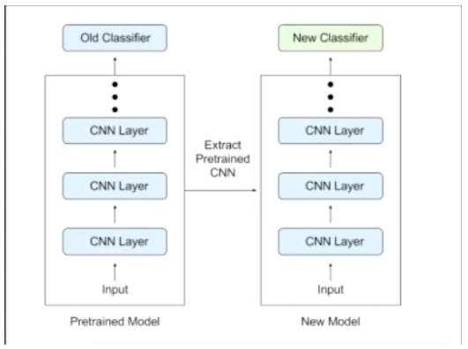

Cut the fully connected layers(classfier) and replace them.

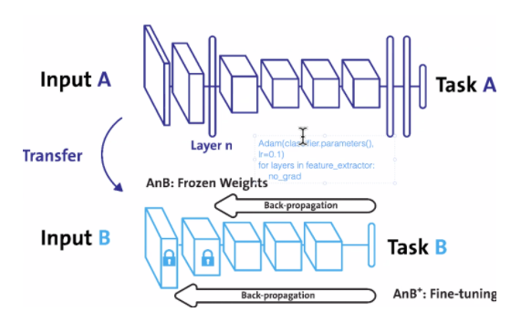

We could also froze weights only for the first layers and do backpropagation on the last layers for specific pattern recognition.

**When to apply?**

Task what is similiar to the previouse model. Only to fine tune the model for the specific task.

**Strategies**

Very small target dataset similiar to the training dataset

* fine tuning the entir emodel could result in overfitting(small data, big model)

Solution: freeze the weights of the Convolutional layers to extract the features and retrain only the fully connected layers(correct numbers of classes)

Big target dataset that is similar to the training dataset

* replace fully connected layers (the classifier) with a new one with random weights and with the correct amount of outputs
* train the entire model

Small target dataset that is very different from the training dataset

only low level features are meaningful that you can find at the first convolutional layers

* freeze the first convolutional layers,drop the high level concolutional layers

Big target dataset very different from the trianing dataset

only low level features are meaningful

* reaplce fully connected layer with a classifier of your choice and retain everything

We are using alread learned "ready" deep learning object for our new object. We are doing this by using last fully connected layer of "ready" model as our first layer.

<https://www.youtube.com/watch?v=K0lWSB2QoIQ>

First we are taking model as "pretrained" . here we are takinh densenet121 model

**Code**

